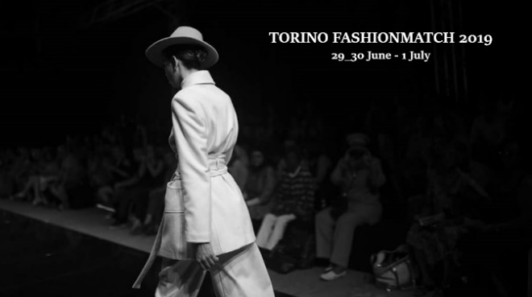 | Programme  Torino Fashion Match 2019
Location:
Palazzo della Luce Building, Via Bertola 40, Turin

Saturday, 29 June 2019
h. 09:00 am -1:00: EEN B2B Session I
h. 1:00 pm – 2:00 Free Lunch

h. 2:.00 pm - 5:30: WORKSHOP I :
- Circular Economy and Sustainability in the Fashion System
- European Case studies on Circular Economy in Fashion and Textile

Sunday 30 June 2019
h. 09:00 am–1:00: EEN B2B Session II
h. 1:00 pm – 2:00 Free Lunch

h. 2:00 pm-5:30: WORKSHOP II:
- Innovate and Digitalize the Fashion System
- The Fashion-Technology Trend

Monday 01 July 2019
h. 09:00 am–1:00: EEN B2B Session II
h. 1:00 pm – 2:00 Free Lunch

h. 2:00 pm-5:30: WORKSHOP III:
- Going International and european funding supports
- Access to finance and Woman Entrepreneurship

29 June 2019
Circular Economy and Sustainability in the Fashion System

h. 14:00 -14:15
Welcome
Mr. Paolo Bertolino
Secretary General, Unioncamere Piemonte (Regional Union of the Chambers of commerce of Piedmont Region)
Enterprise Europe Network partner| Alps EEN consortium
____________________________________________________________________________________________________________

h. 14:15 – 14:30
Camera Italiana Buyer Moda (CBI) – The Best Shops (Italian Chamber of Fashion buyer) tbc
President
____________________________________________________________________________________________________________

h. 14:15 -15:00
Title:
Ms. Marina Spadafora
CEO and Founder of Fashion Revolution Italy
____________________________________________________________________________________________________________

h. 15:00 – 15:30
Mr. Corrado Carbonato
Politecnico di Torino Dip. Design

____________________________________________________________________________________________________________

h. 15:30 – 16:00
Title
Ms. IED, Design European Institute (Turin- Italy)
____________________________________________________________________________________________________________

h. 16:00 – 16:30
Sustainability in the Fashion Industry
Mr. Danny Casimir
Founder and CEO at SPLEXS International Trade

European Case studies on Circular Economy in Fashion and Textile

h. 16.30 – 17.30

- Anaïs Renaud (UK)
Ms. Anais Kelly, Founder and Owner at Anaïs Renaud

- Back to Eco (Spain)
Ms. Nuria Nubiola, Ceo at Back to Eco

- Vintage for a cause (Portugal)
Ms. Helena Antonia Silva, Founder & General Director at Vintage for a Cause
- Atlantic Leather (Iceland) tbc
Mr. Sigurlaug Vordís Eysteinsdóttir, Sales Manager at Atlantic Lather

End of work

30 June 2019
Innovate and Digitalize the Fashion System
The Fashion-Technology Trend

h. 14:00 -14:05 Welcome
____________________________________________________________________________________________________________
h. 14:05 -14:20
How to protect your IPR in Italy
Mr. Valerio Capasso
Lawyer at Saglietti Bianco
____________________________________________________________________________________________________________
h. 14:20 – 14:45
Innovation Management in a Digital Economy
Mr. Marco Gorini
Italian Expert delegate at ISO Technical Committiee on Innovation Management
____________________________________________________________________________________________________________

h. 14:45 – 15:00
Innovation in Fashion Trade
Mr. Danny Casimir
Founder and CEO at SPLEXS International Trade
______________________________________________________________________________________________________

h. 15:00 – 15:30
.........Italian Department Fashion Store
Ms.
La Rinascente (Torino)
____________________________________________________________________________________________________________

h. 15:30 – 16:00
Social Media and Digital Marketing in Fashion System
Ms. Nour El-Mohri
Founder of Taam Media
____________________________________________________________________________________________________________

h. 16:00 – 16:15
How to create an Innovative Fashion brand: Actually, tricks and tips !
Ms. Bali Lawal
CEO and Founder A Coded World, fashion brand
____________________________________________________________________________________________________________

Design based consumer goods
Innovative european platforms _ case studies

h. 16:15 – 16:40
E-Biz-4.0
Mr. Enrique Montiel
Coordinador eBIZ 4.0 Project (Under COSME Euoropean program)
____________________________________________________________________________________________

The Fashion Tech Trend

h. 16:40 – h. 17.15
Technology connected Fashion
Ms. Tanya James MBA
Curator at Fashion Tech Week NY

End of work

1 July 2019
Going International and european funding supports
Access to finance and Woman Entrepreneurship

h. 14:00 -14:15
Welcome
Mr. Paolo Bertolino
Secretary General, Unioncamere Piemonte (Regional Union of the Chambers of commerce of Piedmont Region)
Enterprise Europe Network partner| Alps EEN consortium
____________________________________________________________________________________________________________

h. 14:15 – 14:30
ETP (European Textile Platform) (tbc)
http://www.textile-platform.eu/
____________________________________________________________________________________________________________

h. 14:30 – 14.45
Fashion into the Fourth Industrial Revolution. Shaping a new fashion-tech paradigm through the DeFINE project.
(Innovative Network of Incubator)
Ms. Paola Bertola
Project Coordinator, Politecnico of Milan (lead partner of the project)
Ms. Chiara di Ludovico
Research Fellow, Politecnico of Milan
____________________________________________________________________________________________________________

h. 14:45 – 15:15
How to find technology partners and international business partners for the fashion industry
Presentation of 2 european project related to creative industry: Worth Project and Re-FREAM
Ms. Korina Molla
International Project Manager at AITEX - Textile Research Institute
____________________________________________________________________________________________________________

h. 15:15 – 15:45
Intellectual Property in the Fashion industry: destination Latin America
Ms. Giovanna Girardi
IP Expert, Latin America IPR SME HELPDESK
____________________________________________________________________________________________________________

h. 15:45 – 16.15
Title: Access to finance in the fashion system - European support -
Ms. Raffaella Bruzzone
Chair of the Thematic point Access to Finance, Geneva Chamber of commerce Enterprise Europe Network Partner

Access to finance and Woman Entrepreneurship

____________________________________________________________________________________________________________

h. 16:15 – 16:30
Sector Group Woman Entrepreneurship (Enterprise Euorope Network)
Ms. Sanja Popović Pantić
Chairperson of Sector Group Woman Entrepreneurship (EEN)
__________________________________________________________________________________________________________

h. 16:30 – 16:45
FACTS, Fashion Apparel Cluster Serbia
Ms. Afrodita Bajic
President of Assembly of Facts
____________________________________________________________________________________________________________

Woman Entrepreneurship_case study
16: 45 – 17:00
AMC Mode Collection (Serbia)
Ms. Marijana Matic
Marketing manager of AMC Afrodite Mode Collection

End of work

