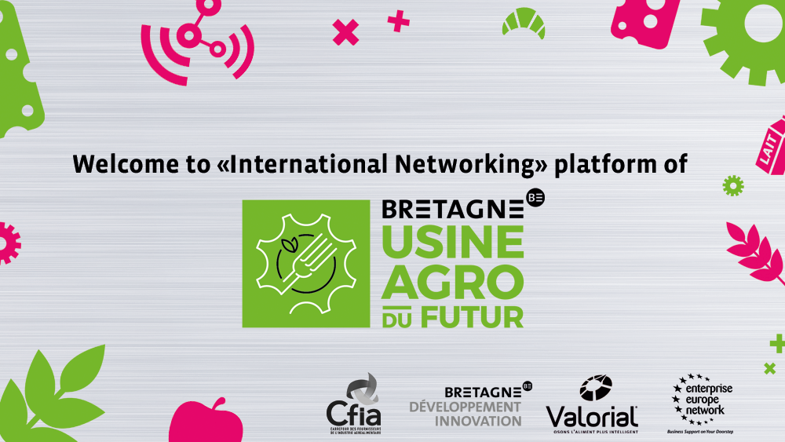

International Networks on “Usine Agro du Futur" booth

March 10th to 12th 2020 at CFIA Rennes 2020, France,
Rennes exhibition centre, Hall 6

For more than 20 years, the CFIA has been the main Food-Process Exhibition in France:
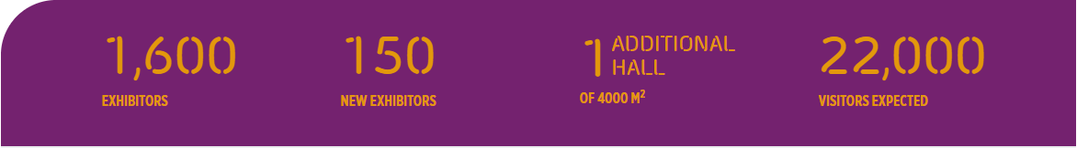
Are you visiting CFIA Rennes 2019? Come to the "Usine Agro du Futur" booth Hall 6, the most attractive area of the CFIA Rennes 2019. There you can:
- Optimize your venue with preprogramed 1-on-1 meetings with visitors or exhibitors. Organised by Enterprise Europe Network, these 20-minute one to one meetings will be a great opportunity for you to connect with promising French and international partners

- Meet the most innovative regional players on food process with the Innovation Gallery Tour, a commented presentation of Usine Agro du future booth, the latest innovative technologies for security in the food industry - English spoken

REGISTER NOW TO PLAN YOUR MEETINGS

Registration free of charge but mandatory on-line before March 09th, 2020
https://cfiarennes2020.b2match.io/

THE EXHIBITION: CFIA

44,000 M2 OF EFFICIENCY AND KNOW-HOW IN THE FOOD-PROCESSING SECTOR
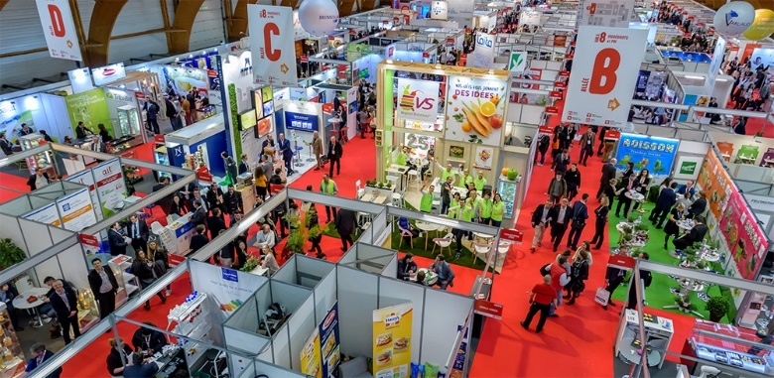
For the last 22 years, CFIA has been the reference exhibition for the food-processing sector in Europe!

It highlights the equipment and know-how of suppliers in the food-processing sector in order to improve the operation of factories.

The offer is divided into three areas: Ingredients & Processed foods, Equipment & Processes, Packing & Conditioning.

PRACTICAL INFORMATION

THE ESSENTIAL (more information on the CFIA web site)
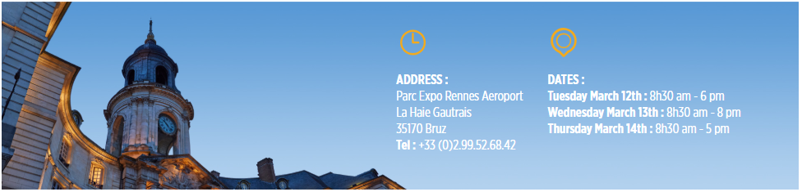

CONTACTS

For the 1 on 1 meetings:
Cécile Guyon / EEN - Bretagne Développement Innovation / c.guyon@bdi.fr / +33 760 296 154
Eric VOULAND / Bretagne Commerce International / e.vouland@bretagnecommerceinternational.com

