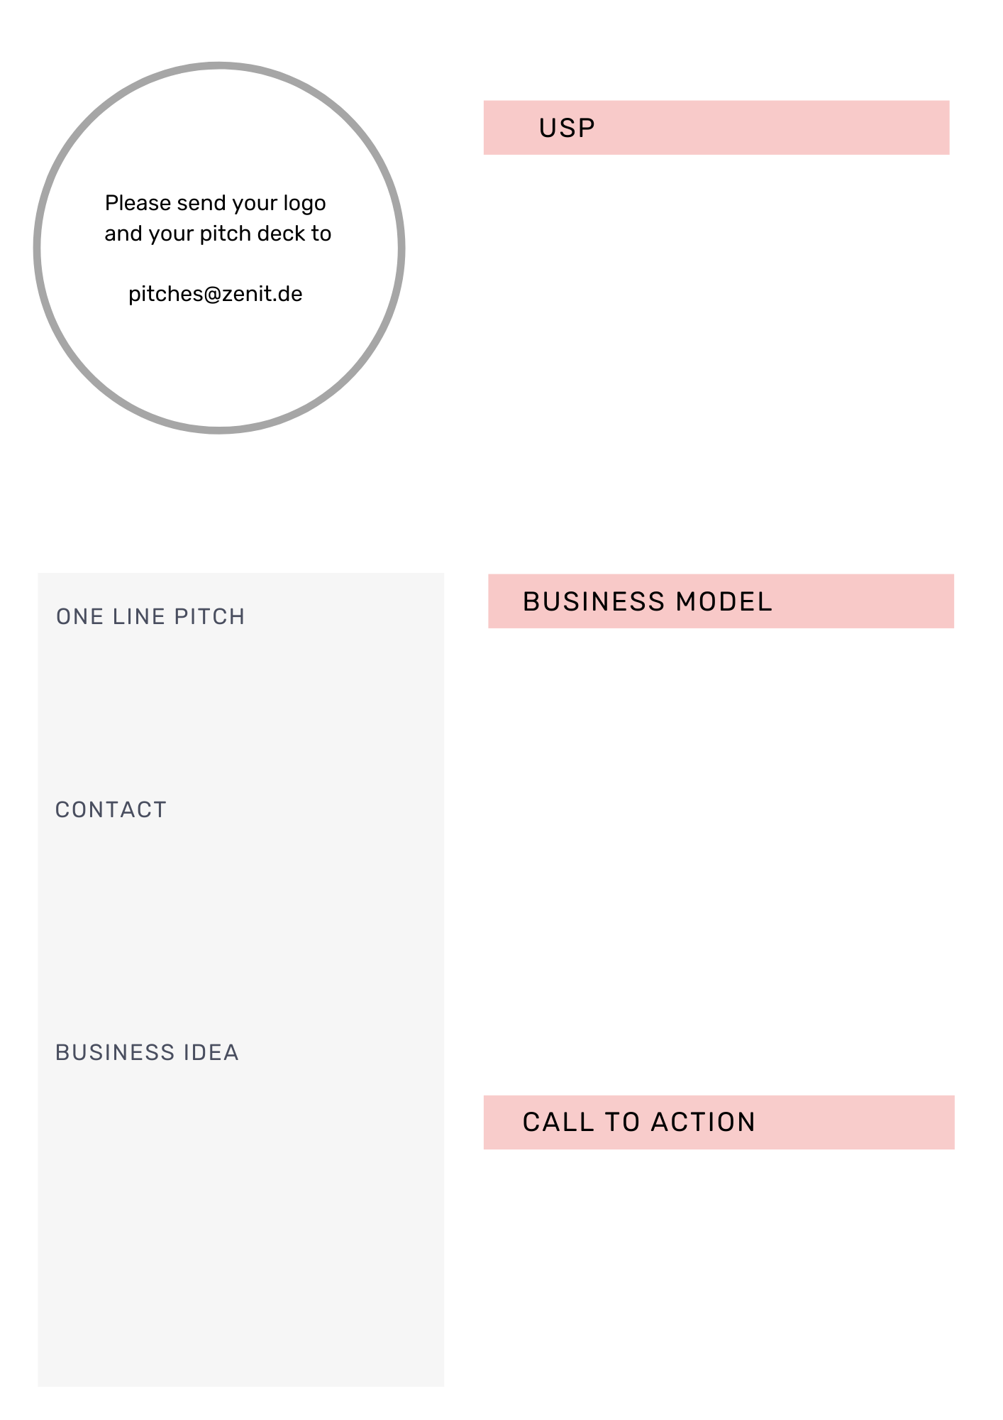

Here you can add your text with up to 150 characters

Contact:

Phone:

Mail:

URL:

Founded on:

Legal form:

Here you can add your text with up to 90 characters

Here you can add your text with up to 515 characters

Here you can add your text with up to 350 characters

Here you can add your text with up to 880 characters