Communication package forum www.connect4geothermal.ch

Content
- Text for two liner
- Text for news
- Text for newsletter
- Program
- Slides for presentation
- Logo
- Picture
- Communication package in German and French
- Contact

Text for two liner
«Connect» in Fribourg / Switzerland on 21.09.2021: THE new Swiss geothermal forum offers a marketplace with cooperation profiles and a broad mix of presentations on decarbonisation with geothermal energy.

Text for news
«Connect» in Fribourg / Switzerland on 21.09.2021: THE new Swiss geothermal forum offers a marketplace with cooperation profiles and a broad mix of presentations on decarbonisation with geothermal energy. Aim is to unleash the geothermal potential. Actual projects and firsthand information on international trends to decarbonize society with geothermal energy will be presented and discussed in interactive sessions with speakers from economics, authorities and research. On top, the forum offers a marketplace with participants profiles to facilitate cooperation among actors from different sectors and strengthen the geothermal value chain. Participants create a profile with their offers and requests. In the online marketplace, they can then choose people whom they would like to meet on a one-to-one basis on 21 September based on common interest. Before the event, everyone receives their personal meeting schedule. The earlier participants register, the more visibility they get for this very effective networking.

Text for Newsletter
Unleash the potential for geothermal energy, 21.09.2021, Fribourg / Switzerland

On 21st of September 2021, the Swiss geothermal energy forum «Connect» will take place, with an international dimension. The aim is to raise the visibility of the different forms of geothermal energy and to strengthen the connections among the different value chain stakeholders. Over 300 participants from Switzerland and abroad are expected. Be part of it and shape the future of a decarbonized society with geothermal energy.

The earth provides lasting heat: a dormant sustainable energy potential beneath our feet. By 2050, geothermal energy can cover at least 25% of Switzerland‘s heating needs in a CO₂-neutral way: a contribution to the energy transition and the reduction of Carbon dioxide emissions. A new value chain with regional jobs is created.

Be part of it and become actor of the energy transition
The deployment of geothermal systems on a large scale requires cooperation between actors from different sectors. Research and development is still needed for some systems. Others are mature and at the market threshold. And many products, services and technologies are already widely used. The use of different geothermal systems differs from one region to another and the knowledge of the subsoil and the legislation are more or less favourable in different countries. Thus, exchanges of experience and knowledge between regions and among actors in the different sectors involved will accelerate the development of the emerging geothermal value chain.

Market for national and international cooperation
The forum is a marketplace for effective connections between authorities (framework conditions), industry (implementation) universities (newest knowledge) and corporates and investors (funding) to unleash the geothermal potential. On the forum platform www.connect4geothermal.ch participants define their profile of interest with their specific knowledge, experience, technologies, products and services. All participants can browse these profiles and select in advance who they are interested to meet 1to1 during the forum. Before the event, everyone receives their personal meeting schedule. This enables effective networking to facilitate integration of partial solutions into complete systems. The new platform will remain online after the event and animated with further activities to facilitate exchanges.

Firsthand information on projects and international trends
Speakers representing economics, authorities and research with experts from geology, energy, environment, urban development will present actual projects and discuss international trends in plenary and interactive parallel sessions. Themes covered are heat and cold in urban areas as well as for industry and agriculture, storage of energy with the subsoil, electricity generation, lithium extraction and CO2 capture as well as better knowledge to protect and use the underground resources.

Register now
Take this opportunity to present your products, services and expertise and to expand your network. The forum offers you a platform to profile your organization. As sooner you register, as longer your profile will be visible. Be part of it!

Program
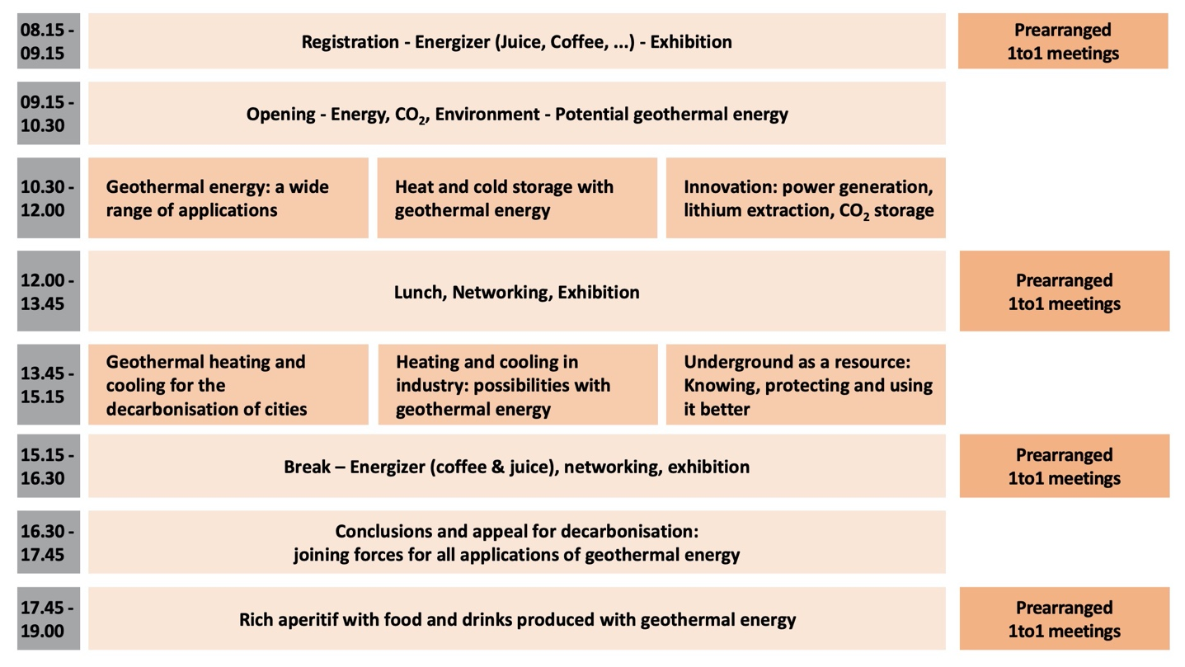
Programme with all speakers is available here.
Synoptic overview:

Slides for presentation
Slides English
Slides German
Slides French

Communication package in German and French
Communication packages in German and in French, as updates are available here.
(Page “Promotion” on www.connect4geothermal.ch)

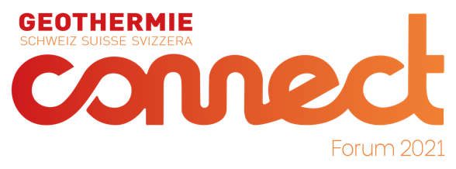
Logo

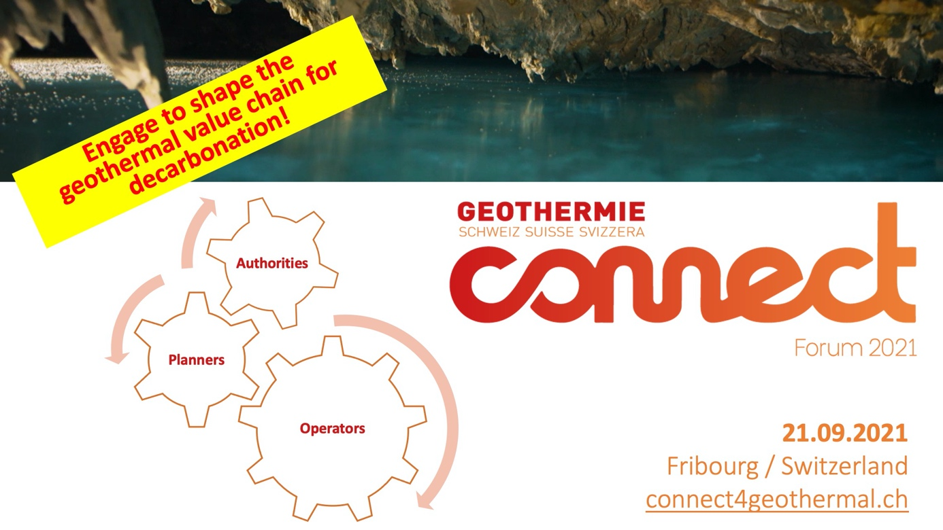
Picture

Contact
connect@geothermie-schweiz.ch
Daniel Stegmann: +41 79 954 88 81
Cédric Höllmüller: +41 79 701 00 76

