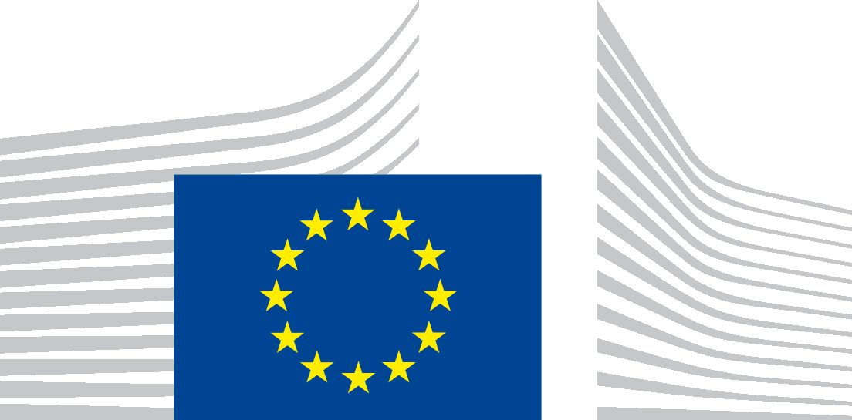 | EUROPEAN COMMISSION  Executive Agency for Small and Medium-sized Enterprises (EASME)
Data Protection Notice for the Matchmaking Event - Towards COVID-19 vaccines upscale production, 29th and 31st of March 2021

Your personal data is processed in accordance with Regulation (EU) No 2018/1725 on the protection of individuals with regard to the processing of personal data by the Union institutions, bodies, offices and agencies and on the free movement of such data.

The data controller of the processing operation is of the processing operation is Head of Unit A1 (COSME) of the Executive Agency for Small and Medium-sized Enterprises
(EASME).

The following entities processes your personal data on our behalf: Sociedade Portuguesa de Inovação (SPI), located at Avenida Marechal Gomes da Costa, 1376, 4150-356 Porto, Portugal. E-mail address: spiporto@spi.pt

The legal basis for the processing activities are:
- Article 5(1)(a) of Regulation (EU) 2018/1725 because processing is necessary for the performance of a task carried out in the public interest (or in the exercise of official authority vested in the Union institution or body);
- Article 5(1)(d) of Regulation (EU) 2018/1725 based on your explicit consent for your non- mandatory personal data indicated below.

The purposes of this processing are to register and manage the participation of interested persons to the “Matchmaking Event - Towards COVID-19 vaccines upscale production”, to provide follow-up activities such as relevant information on the event and subject matter, and to follow-up with the participants for event related feedback.

The following of your personal data are collected: your first name, last name, job position/title, country, phone number and e-mail address are mandatory for the purpose(s) outline above.

In addition, the following non-mandatory personal data may be collected: your photos, videos, your LinkedIn/Twitter account, which you may have the opportunity to provide if you want, and will only be processed based on your explicit prior consent.

Please note that the event will include two preparatory webinars and it is possible that you will be recorded. It is also possible that photographs of you will be taken during the event and might be used for related communication purposes.

The recipients of your personal data will be: the contractor SPI in charge of the organisation of this Matchmaking Event and the contractor Ecorys Europe EEIG-GEIE; the European Clusters Alliance (ECA) and the Council of European BioRegions (CEBR); the members of the European Commission “Task Force for Industrial Scale-up of COVID-19 vaccines”; EASME and the European Commission staff in charge of this Matchmaking Event. The collected personal data might also be communicated to bodies charged with monitoring or inspection tasks in application of EU law (e.g. internal audits, Court of Auditors, European Anti-fraud Office (OLAF)).

Your personal data will not be transferred to third countries or international organisations. Please also note that the ECCP uses a third-party tool (see below) with their own privacy policy, which you are strongly suggested to read carefully.

The processing of your data will not include automated decision-making (such as profiling).

Your personal data will be kept for a maximum period of 9 months after the event. Data will be manually deleted at the end of this period.

You have the right to access your personal data and to request your personal data to be rectified, if the data is inaccurate or incomplete; where applicable, you have the right to request restriction or to object to processing, to request a copy or erasure of your personal data held by the data controller. If processing is based on your consent, you have the right to withdraw your consent at any time, without affecting the lawfulness of the processing based on your consent before its withdrawal.

Your request to exercise one of the above rights will be dealt with without undue delay and within one month.

If you have any queries concerning the processing of your personal data, you may address them to Head of Unit A1 (COSME) (entity acting as data controller) via: eumatchmaking@clustercollaboration.eu

You shall have right of recourse at any time to the EASME Data Protection Officer at EASME-DPO@ec.europa.eu and to the European Data Protection Supervisor at https://edps.europa.eu.

Third party tool
B2Match
For the purpose of facilitating match-making events, B2Match, a third-party tool managed by SPI, collects personal data. B2Match’s privacy policy can be found here: https://www.b2match.com/privacy-policy

Regulation (EU) 2018/1725 of the European Parliament and of the Council of 23 October 2018 on the protection of natural persons with regard to the processing of personal data by the Union institutions, bodies, offices and agencies and on the free movement of such data, and repealing Regulation (EC) No 45/2001 and Decision No 1247/2002/EC (OJ L295/39 of 21.11.2018).
Regulation (EU) No 1287/2013 of the European Parliament and of the Council of 11 December 2013 establishing a Programme for the Competitiveness of Enterprises and small and medium-sized enterprises (COSME) (2014 - 2020).
Act of Establishment: Commission Implementing Decision C(2013/771/EU) of 17 December 2013 establishing the 'Executive Agency for Small and Medium-sized Enterprises' and repealing Decisions 2004/20/EC and 2007/372/EC.

